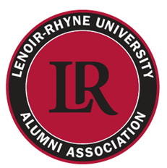
LRU Alumni Board of Directors
2015 Nomination Form
Board Prospect Names

NAME: ______________________________

YEAR OF GRADUATION (Undergraduate or Graduate School?):___________

PLACE OF EMPLOYMENT & POSITION (if known):____________________

CITY OF RESIDENCE: _________________________________

PHONE #:______________________________ E-MAIL:____________________

BACKGROUND (if known) &/or WHY YOU FEEL THEY WOULD MAKE A GOOD ALUMNI BOARD MEMBER:
NAME OF PERSON RECOMMENDING: ____________________________

YOUR E-MAIL ADDRESS: _______________________________
NAME: __________________________________

YEAR OF GRADUATION (Undergraduate or Graduate School?):___________

PLACE OF EMPLOYMENT & POSITION (if known):____________________________________

CITY OF RESIDENCE: __________________________________

PHONE #:____________________________ E-MAIL:_________________________________

BACKGROUND (if known) &/or WHY YOU FEEL THEY WOULD MAKE A GOOD ALUMNI BOARD MEMBER: ___________________________________________________________________

NAME OF PERSON RECOMMENDING: ______________________________________
YOUR E-MAIL ADDRESS: __________________________________________
SUBMISSION DEADLINE: Friday, January 2, 2015
Email Form to lru.director@alumni.lr.edu

